Inventing A Game Controller To Increase Engagement At Ontario Tech University’s Annual Student Game Con Event

Alexandre Anastasakis  
Idustrial Design For Game Hardware  
Ontario Tech UniversityOshawa, Canada  
alexandre.anastasakis@ontariotechu.net

***Abstract*— Ontario Tech University’s Game Development and Interactive Media Program hosts an annual student Game con event in April that is attended by industry scouts, professors, other students, alumni from the program, and the public. Participants in this event show off their showpiece of the year and hope for passersby to stop and play their game. As up and coming game developers, we want to stand out to be seen, to be validated, to network and to compete. The goal of this project is to attract more attention from the crowd and give a more memorable gameplay experience to players. Engagement in video games is influenced by many factors, however this project aims to produce a unique controller that increases engagement via physical involvement in the game. The result of this assignment is a prototype of a three-part device connected by wires that functions like a game of Whack-a-Mole. The biggest takeaway from this assignment is underestimating the learning curve of new software.**

(*Abstract*)

# Introduction

As described in the previous assignment, the designing is for a three-part device that includes a hammer, a box with a striking face and a foot pedal to create kinesthetic engagement for more arcade-like gameplay. This is a three-part device, connected by wires, with the brain of the system residing in the box. The previous assignment explained the need for a robust system. The hammer needs to be strong, light and responsive. The pedal needs to be thin, yet also sturdy and responsive, and the box needs an appealing LED display for user feedback, preferably a light strip that can be used as a force meter that displays the force sensed over a range. Also, for the sake of being able to inspect parts after use, each part of the device needs to be non-destructively dismantlable, and completely secured when assembled. The design was done in FreeCad [5] rather than Fusion360 [1] due to an interest in trying out a new software. The most pressing challenge was in finding good materials because PLA will not last up against prolonged abuse. I was able to find all needed materials were in my garage or around the house that came from old personal projects, which greatly helps lower the cost.

# Results

## The Box

The reasoning behind the box having rubber feet is that the final design requirement is ambiguous. This device will be used at the end of next semester. Therefore, without the booth design, it is unclear how to handle cable management. Therefore, it was decided to defer that decision. For the moment, cables coming from the pedal and the hammer will run under the walls, and if needed, secured to the walls near the microcontroller using an adhesive. Currently, the plan to manage wiring from the components in the box to the microcontroller is by using color-coding and zip-ties. The LED bar container uses a flexible clipping mechanism that should lock itself in when slid in. By pressing on the locking tabs, the LED bar should be easily removable with medium effort. In the design of the box, the only ergonomic design consideration was in the width of the box. The box is around shoulder width which should provide a large enough strike face for the user to comfortably and confidently swing the hammer without damaging nearby objects or hitting themselves. The design files include an STL of an Arduino Nano [2] and a breadboard [4] taken from Thingiverse [3].

## The Hammer

The hammer is attached to the box with a wire. This wire serves as a mock retention cable and a data cable. Below the handle is a plug glued into the base of the handle that will lock the wire at a certain length, to prevent damage on the components inside the hammer by excessive pulling on the wire. The design of the hammer allows for complete rigidity when fully assembled, and a non-destructive disassembly. When assembled, the shell, made from a PVC pipe, needs to slide on. The cut along the bottom allows for the pipe to be stretched open enough to slide the hammer head and handle assembly in. Regarding ergonomics, the size is what is considered. It was decided that the shape of a small mallet allowed for less weight and is more enjoyable to handle.

## The Pedal

The pedal is tricky. It needs to be thin, sensitive and large. As no tests were done with the current design, cable management is not being considered. Otherwise, the piece of foam underneath is held in place by extruded corners on the pressure plate. The ergonomics of this design is tricky and needs further testing. Currently, the idea is having a thin pedal for a smaller height clearance to be able to step on it easily.

# Conclusion and Future Work

In terms of takeaways, the use FreeCad [5] has been a disappointment because the software is not as efficient to use as Fusion360 [1]. The models will break much easier and a different, non-intuitive approach is required to designing CAD models that won’t break when modifying its parameters. It is also very difficult to switch from one to the other once the project has begun. In retrospect, it would have been wiser, considering the time constraints, to stick to the better software rather than experiment with a new software. Overall, is moving in a promising direction.

##### Appendix A: The circuit board and the connections to its peripherals.

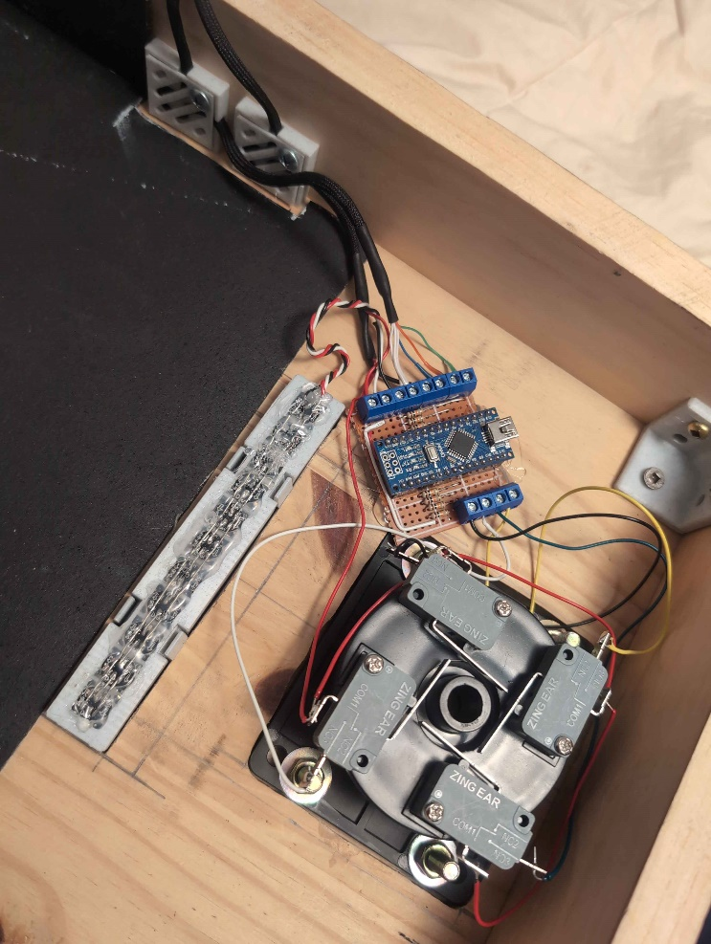

##### Appendix B: The equivalent circuit of the system.

##### 

##### Appendix C: table showing the result of the SUS survey.

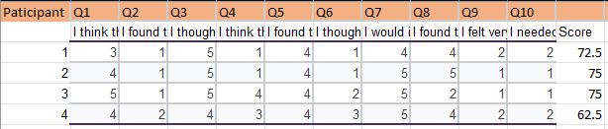

##### Appendix D: graph visualizing the result of the SUS survey.

##### References

1. *Autodesk fusion: 3D CAD, CAM, CAE, & PCB cloud-based software*. Autodesk. (2024, November 7). <https://www.autodesk.com/ca-en/products/fusion-360/overview>.
2. *Your own 3D parametric modeler*. FreeCAD. (n.d.). <https://www.freecad.org/>.